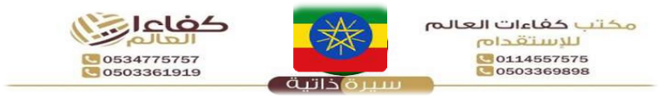

{%facePhoto} |  |  |  |  | Reference Number |  |  |  | {refNumber}
 |  |  |  |  | Full Name |  |  |  | {fullName} |  |  |  |  |  | الاسم
 |  |  |  |  | Religion |  |  |  | {religion} |  |  |  |  |  | الديانة
 |  |  |  |  | Position Desired |  |  |  | {position} |  |  |  |  |  | الوظيفة
 |  |  |  |  | Salary |  |  |  | {salary} |  |  |  |  |  | الراتب
 |  |  |  |  | Age |  |  |  | {age} |  |  |  |  |  | العمر
 |  |  |  |  | Sex |  |  |  | {gender} |  |  |  |  |  | الجنس
Personal Information |  |  |  |  |  | معلومات شخصيه |  | Passport Information |  |  |  |  |  |  |  | معلومات الجواز
Nationality |  |  | {nationality} |  |  | الجنسية |  | Number |  |  |  | {passportNumber}
Date of Birth |  |  | {dob} |  |  | تاريخ الميلاد |  | Issue Date |  |  |  | {issueDate} |  |  |  | الإصدار
Address |  |  | {address} |  |  | العنوان |  | Expiry Date |  |  |  | {expiryDate} |  |  |  | الانتهاء
Marital Status |  |  | {maritalStatus} |  |  | الحالة الاجتماعية |  | Issue place |  |  |  | {issuePlace} |  |  |  | الاصدار
No. of Children |  |  | {numberOfChildren} |  |  | عدد الأطفال |  | Next of Kin name |  |  |  | {emergencyName} |  |  |  | خص
Height/Weight |  |  | {height} / {weight} |  |  | الوزن والطول |  | Next of Kin number |  |  |  | {emergencyPhone} |  |  |  | رتب
Education Qualifications |  |  | {educationLevel} |  |  | المستوى التعليمي |  | {%fullBodyPhoto}
Tel. Number |  |  | {phone} |  |  | رقم التواصل
Overseas Experience |  |  |  |  | خبرات سابقه
Country |  |  | Period |  | Position
{expCountry} |  |  | {expPeriod} |  | {expPosition}
Skills |  |  |  |  | المهارات
Cooking |  | {skillCook} | الطبخ | Baby Sitting |  | {skillBaby} | التعامل
Washing |  | {skillWash} | الغسيل | Sewing |  | {skillSew} | الخياطة
Cleaning |  | {skillClean} | التنظيف | Driving |  | {skillDrive} | سائق
Languages |  |  |  |  | اللغات
 |  | English  الانجليزية |  |  | Arabic  العربية
Good |  | {english} |  |  | {arabic}
Fluent |  | NO |  |  | NO
REMARKS: SHE IS HARDWORKING, NEAT, ORGANISED, SMART, DISCIPLINED, CARING, HAS A GOOD ATTITUDE, SPEAKS GOOD ENGLISH AND LOVES TAKING CARE OF CHILDREN.

Scan for Video / QR Code
{%qrCode}

Passport Image
{%passport image}

